Project Design Phase-II
Data Flow Diagram & User Stories

Date | 26-05-2025
Team ID | LTVIP2025TMID53093
Project Name | House Hunt
Maximum Marks | 4 Marks

Data Flow Diagram (DFD) Overview – House Hunt
A Data Flow Diagram (DFD) illustrates how data moves through the House Hunt application. It captures the interaction between users (Renters, Owners, Admins) and the system’s core functionalities.

Level 0 – Context Diagram
This high-level diagram shows external users interacting with the system:
- Renters: Register, log in, browse properties, and book visits.
- Owners: Register, get admin approval, list properties, and manage bookings.
- Admins: Approve owners, manage users and listings.
- The system communicates with a central MongoDB database to store user, property, and booking data.

Level 1 – Process Breakdown
Breaks down the core system into modules:
- User Authentication: Handles login/signup, JWT generation, and secure storage.
- Property Management: Enables property listing updates, image uploads, and saves data.
- Browsing & Filtering: Provides search filters and displays matching listings in real time.
- Booking Management: Allows booking requests, owner approval, and status updates.
- Admin Controls: Admin can manage users, approve owners, and moderate listings.
- Notifications: Sends updates and shows real-time booking statuses.

Data Stores
- Users: Renters, Owners, Admins
- Properties: Listings and metadata
- Bookings: Requests and status history
All data is managed using MongoDB + Mongoose for structure and validation.

External Entities
- Renter: Browses and books properties
- Owner: Manages listings and booking responses
- Admin: Oversees platform activities
Communication occurs via Express.js REST APIs.

Let me know if you want this added to a Word or PDF document.

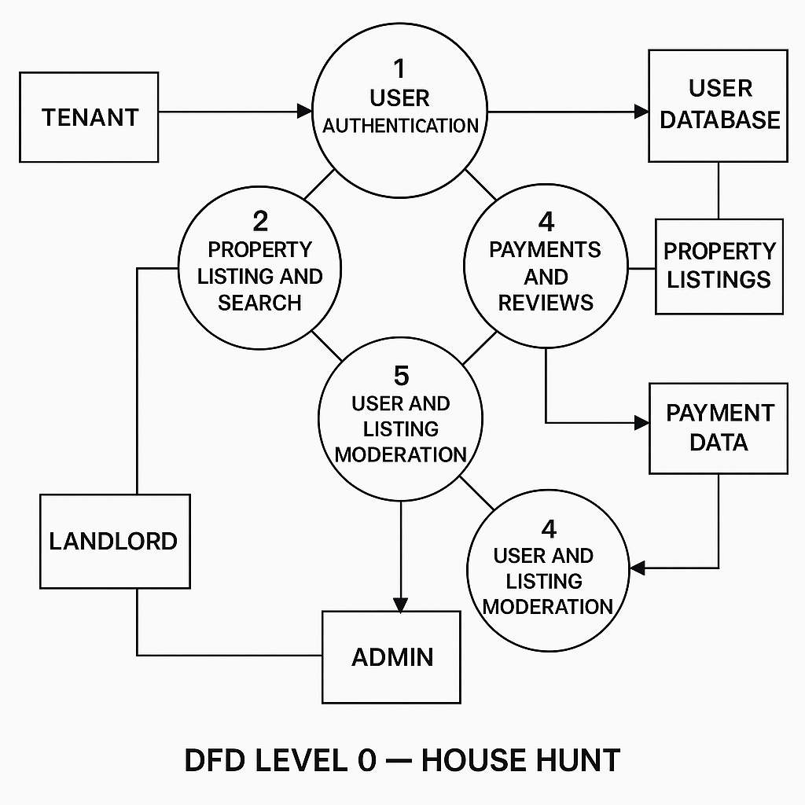

User Stories

User Story Table – DocSpot
User Type | Functional Requirement (Epic) | User Story / Task | Acceptance Criteria | Priority | Release
Tenant | Property Discovery & Booking | As a tenant, I can search for rental properties by location, budget, and features. | Listings returned based on filters and relevance.. | High | Sprint-1
 | Booking Visits | As a tenant, I can book, reschedule, or cancel property visits. | Visit status updates in  dashboard  . | Medium | Sprint-2
Landlord | Listing  Management | As a landlord, I can create and update  property listings with images and  availability. | Changes reflect immediately in patient booking system. | High | Sprint-1
User | Messaging | As a user, I can chat with the other party in real-time | Messages appear instantly. | Medium | Sprint-2
Admin | Profile Management | As a Admin, I can update my profile. | Changes are saved successfully. | High | Sprint-2
Client | Payment Processing | As a client, I can make secure payments after job completion. | Payment recorded and shown in transaction history. | High | Sprint-2
user | Review System | As a user, I can leave a review after project closure. | Review appears on profile. | Medium | Sprint-2
Admin | User Moderation | As an admin, I can review reported users and take action. | Reports and actions logged. | High | Sprint-1

